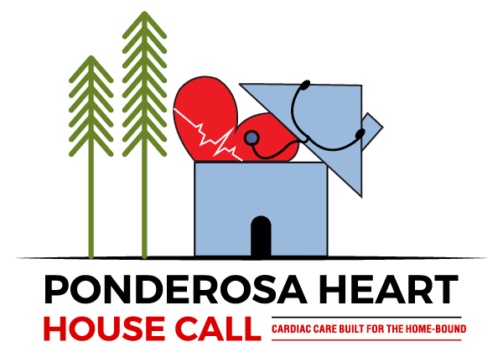

Enrollment in Principle Care Management (PCM)

The Ponderosa Heart House Calls' Principal Care Management (PCM) program is a specialized service for patients with a single, complex chronic heart condition.
This program aims to coordinate care, improve health, and reduce the risk of hospitalization through a dedicated team of Advanced Practitioners, Nurse Case Managers, Clinical Operations staff, and Scheduling team members.

HOW DOES PCM WORK?
The PCM program focuses on managing one complex cardiac condition, such as heart failure, atrial fibrillation, coronary artery disease, exc. It is designed for patients who face a significant risk of functional decline or hospitalization.
This specialized approach differs from standard chronic care management (CCM), which is for patients with multiple chronic conditions and is usually completed by a Primary Care Provider.

The program relies on a multidisciplinary team to deliver coordinated, comprehensive care.
- Advanced Practitioners (APs): These licensed professionals, including Nurse Practitioners (NPs) and Physician Assistants (PAs), perform clinical assessments, create personalized care plans, and provide ongoing monitoring of a patient's condition. They also coordinate with other providers and specialists such as your Primary Care Provider or specialty testing centers.
- Nurse Case Managers: This role serves as the central point of contact for the patient and family. The case manager helps coordinate care, assess appointment need, and provides patient education. They also work with health insurers to manage coverage.
- Clinical Operations Staff: This team works behind the scenes to ensure the program runs smoothly. They manage logistics, track regulatory compliance, and handle the day-to-day administration, allowing the clinical team to focus on patient care.
- Scheduling Staff: The close collaboration between scheduling staff and nurse case managers ensures patients are seen promptly by addressing clinical urgency and logistical needs. This partnership optimizes workflow, enhances communication, and ultimately improves patient experience.

WHAT ARE THE SERVICES AND BENEFITS FOR PATIENTS?
Enrolling in the PCM program can lead to better health outcomes and a higher quality of life for patients with complex Cardiac conditions. Services are typically delivered remotely through phone and electronic record review which may include:
- Individualized care plans: The team develops a personalized plan with the patient to outline treatment goals and monitor progress.
- Regular monitoring: The program offers monthly clinical reviews and ongoing communication, often using weight.
- Care coordination: The Ponderosa team coordinates with our patient’s other providers, such as primary care physicians and other specialists, to ensure seamless communication and a cohesive treatment strategy.
- Patient education: Patients and their families receive education on managing their condition, including medication adherence and lifestyle modifications.
- Reduced hospitalizations: Proactive, coordinated management is designed to stabilize chronic conditions, identify issues early, and reduce emergency room visits and hospital readmissions.

HOW MUCH DOES PCM COST THE PATIENT?
Who pays for Principal Care Management (PCM) depends on the patient's insurance and financial situation. In most cases, it is paid for by a combination of public insurance (like Medicare or Medicaid) and private insurance plans. Ponderosa Heart House Call will never bill our patients for any expenses related to PCM.

